Growing Up A Star

This activity helps students understand and interpret the Hertzsprung Russell (HR) diagram – a graphical representation of how stars evolve that is useful to astronomers.

Materials Needed.

• Chart of “Main Sequence” stars, “Super Giant” stars, and “Dwarf Stars” (see attached sheet)
• HR Diagram
• Graph paper

• Pens, pencils
• Optional: YouTube video: http://www.spacetelescope.org/videos/heic1017b

What To Do:

- For homework, have students take some data from home. They should get the heights and weights of all the people living in their home, including newborn babies and small children (ask the adults to be honest about their weight). Weight should be in lbs. Height should be in inches. Students should also collect ages of these people.

Stage | Age (in years) | Height (in inches) | Weight (in pounds)
Child | 10 | 50 in | 86 lbs
Adult | 45 | 72 in | 186 lbs
Adult | 38 | 66 in | 146 lbs

- Have students work together in groups of 3 - 5. They should gather up their height/weight data and examine the results. Are there any patterns?

- Have the groups of students create a graph of the height/weight data using the attached graph paper. The axes of the graph should look like this.
Height (in)
Weight (lbs)

- What do the students notice about their graphs? Where do “adults” cluster on the graph? Where do newborn babies cluster? Children? Or is there no clustering at all? Describe the shape of the graph? Is it a straight line? A curve?

- Give each group the list of stars attached and the HR diagram attached. Instead of height and weight, the information is in Luminosity (compared to sun) and Surface Temperature (in K). The chart also gives the star’s current status as either a main sequence star* (adulthood for stars), a giant (beginning of old age), or a dwarf (near death). *Main sequence stars – that is, stars that are currently fusing hydrogen in their cores and have not yet depleted their reserves of fusible hydrogen.

- Have students fill out the star chart using by reading off values from the HR diagram.

- What do the students notice about the HR Diagram? Where do “main sequence stars” cluster on the graph? Where do dwarfs cluster? Giants? Describe the shape of the graph Is it a straight line? A curve? What is unusual about the axes?
What’s Going On?
There are two characteristics of human beings that are related, evolve predictably as we age, and show a bit of variation from person to person. These variables are height and weight. Babies (defined as the height and weight at birth), children (defined as humans who are still growing in height), adults (defined as humans whose height is stable), and the elderly (defined as nearing the end of life) all have weights and heights that vary, but have normal ranges that show up as “clusters” of points on a graph of height vs. weight.

Height (in)
Weight (lbs)
Adults

Children

Newborns

You can also use a graph of height and weight to show how humans “evolve” over a typical lifetime. The graph below shows an example of how someone might develop from newborn baby to child to adult to an elderly person on such a graph.

Height (in)
Weight (lbs)
Adults

Children

Newborns

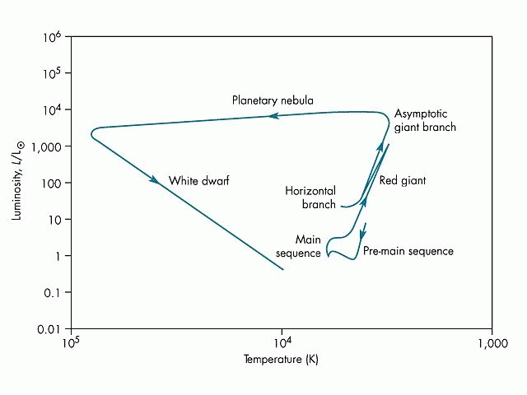
How does a graph of height and weight relate to the HR diagram? There are two stellar variables that, like height and weight, are characteristics of stars that evolve as stars age. These are luminosity and surface temperature. A graph of the luminosity vs. surface temperature for stars at various stages (e.g. protostars (“baby stars”), main sequence stars (“adult” stars), post main sequence stars (“elderly” stars), and white dwarfs, neutron stars, and black holes (dead stars), shows patterns. Main sequence stars lie along a narrow path. The other stages clump together in different parts of the HR diagram. The HR diagram below shows the evolution of the Sun.

SOME FAMOUS STARS

Name | Luminosity (Compared to Sun) | Surface Temperature  (K)
Sun | 1 | 5500
Altair
Sirius
Regulus
Achemar
Barnard’s Star
Proxima Centauri
Rigel
Deneb
Canopus
Betelgeuse
Antares
Mira
Aldebaran
Sirius B
Procyon B

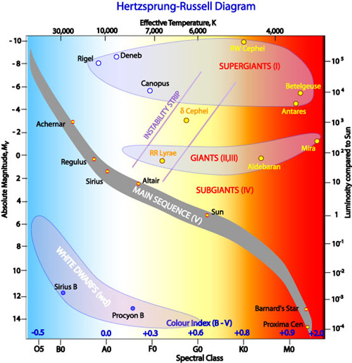
Types of Main Sequence Stars
**Only Boys Accepting Feminism Get Kissed Meaningfully”

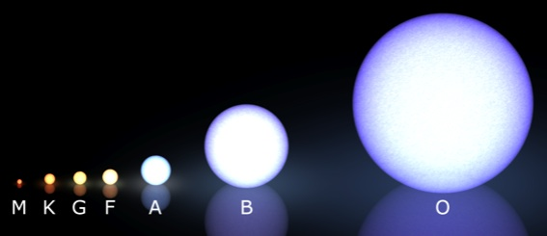

Spectral  Type* | Surface  Temperature | Size (in solar diameters) | “Color”
O  B  A  F  G  K  M | 33,000-100,000K  10,000-33,000K  7,500-10,000K  7,500 -6,000K  5,200 – 6,000K  3,700-5,200K  ≤ 3,700K | 12 - 25  4 - 12  1.5 - 4  1.1 - 1.5  0.85 - 1.1  0.6 - 0.85  0.1 - 0.6 | Bluest  Bluish  Blue-White  White  Yellow-White  Orange  Red

OBAFGKM – More Detail
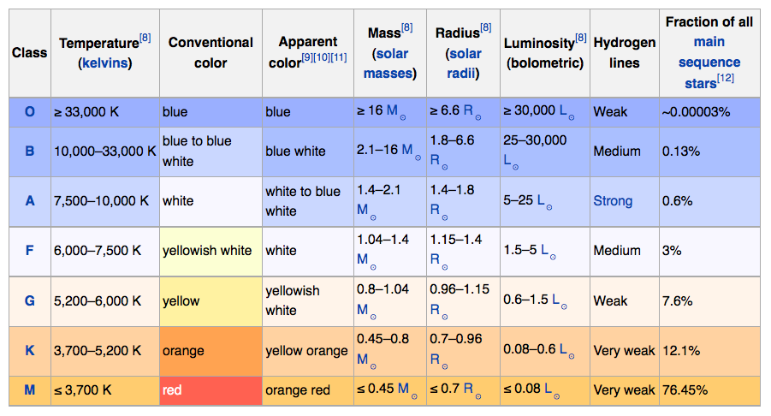
**Only Boys Accepting Feminism Get Kissed Meaningfully”

Luminosity is the energy output of a star in Watts. Sometimes energy is expressed as “absolute magnitude” which is a measure of how bright a star actually is if all the stars were the same distance away from earth.
Surface temperature is a measure of the temperature (in Kelvin) of a star’s very upper atmosphere. Remember, stars have no real “surface”. Sometimes temperature is expressed as a color temperature. The hotter the star’s surface temperature, the bluer it appears. The cooler the surface, the redder it appears. Astronomers can also describe surface temperature (or color temperature) as a star’s spectral class. O stars are hottest and bluest. B stars are less blue, more white, and cooler. M stars are the reddest and coolest. The entire color spectrum from hottest to coolest surface temperature is O B A F G K M (or…using my very favorite pneumonic, Only Boys Excepting Feminism Get Kissed Meaningfully).

